Apol Medrano
Heritage University 09-11-23
Mathematics and Computer Science Dept. Due: 09-17-23

C++
Homework 3
(functions )

1: Please work with functions and giving the values of an item try get the value with tax (5% sales tax). A message on the screen has to inform you for next item insertion or exit.

//HW3 Q1
//Apol Medrano
#include <iostream>
using namespace std;

double totalCost(double PricePar);
//taking the price of item and adding 0.05 sales tax to it

int main ()
{
double price;

cout.setf(ios::fixed);
cout.setf(ios::showpoint);
cout.precision(2); //display money properly

while (price!=0)
{
cout << "What is the price of the item you have? \n";
cin >> price;
cout << "The total cost is: $" << totalCost(price) << endl;
}
return 0;
}

double totalCost(double PricePar)
{
const double SALES_TAX = 0.05 * PricePar; //0.05 sales tax
double totalCost = PricePar + SALES_TAX; //tax added on to item price

return (totalCost);
}

Q1 OUTPUT:
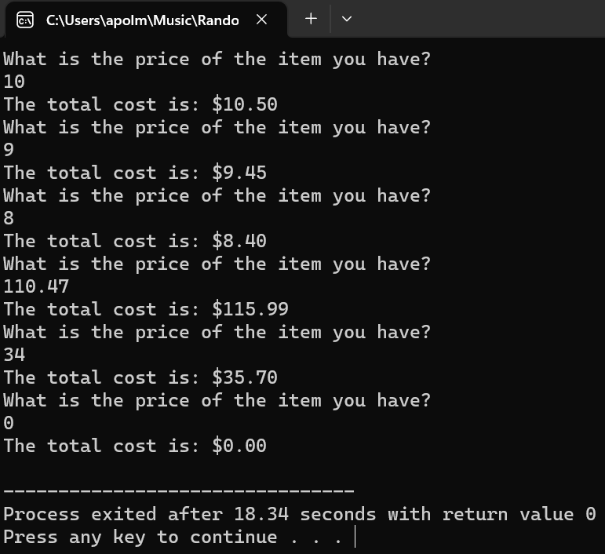

2. Please find from three numbers the min and max using only one function

//HW3 Q2
//Apol Medrano
#include <iostream>
using namespace std;

void order(int numberPar1, int numberPar2, int numberPar3);
//find the max and min of 3 numbers

int main ()
{
int num1, num2, num3;

cout << "Number 1: ";
cin >> num1;
cout << "Number 2: ";
cin >> num2;
cout << "Number 3: ";
cin >> num3;

order(num1, num2, num3);

}

void order(int numberPar1, int numberPar2, int numberPar3)
{
int min = numberPar1, max = numberPar1;

//find min
if (min > numberPar2)
min = numberPar2;
if (min > numberPar3)
min = numberPar3;
cout << "The mininum number is: " << min << endl;

//find max
if (max < numberPar2)
max = numberPar2;
if (max < numberPar3)
max = numberPar3;
cout << "The mininum number is: " << max << endl;
}

Q2 OUTPUT:
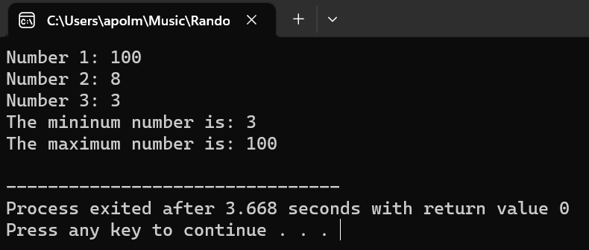

3. Write a program that allows the user to enter a number of quarters, dimes, and nickels and then outputs the monetary value of the coins in cents. For example, if the user enters 2 for the number of quarters, 3 for the number of dimes, and 1 for the number of nickels, then the program should output that the coins are worth 85 cents.

//HW3 Q3
//Apol Medrano
#include <iostream>
using namespace std;

double coinValue(int quartersPar,int dimesPar,int nickelsPar);
//take number of coins, return monetary value

int main()
{
int quarters, dimes, nickels;

cout << "How many quarters: ";
cin >> quarters;
cout << "How many dimes: ";
cin >> dimes;
cout << "How many nickels: ";
cin >> nickels;

cout << "The monetary values of the coins is $" << coinValue(quarters,dimes,nickels);
}

double coinValue(int quartersPar,int dimesPar,int nickelsPar)
{
double quarterValue = quartersPar * 0.25, //0.25 nickels value
dimesValue = dimesPar * 0.10, nicklesValue = nickelsPar * 0.05, totalValue;
//0.10 dimes value & 0.05 nickels value
totalValue = quarterValue + dimesValue + nicklesValue;
//all the coins added up
return (totalValue);
}

Q3 OUTPUT:
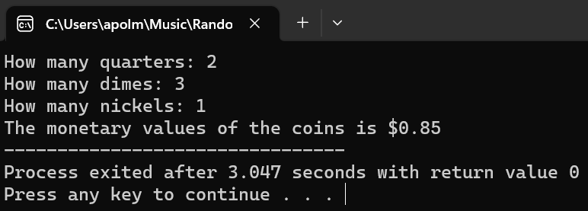

4. Write a program that allows the user to enter a time in seconds and then outputs how far an object would drop if it is in freefall for that length of time. Assume that the object starts at rest, there is no friction or resistance from air, and there is a constant acceleration of 32 feet per second due to gravity. Use the equation:
distance = (acceleration * time²) / 2
You should first compute the product and then divide the result by 2

//HW3 Q4
//Apol Medrano
#include <iostream>
using namespace std;

double distance(double timePar);
//calculate distance object would fall
//during freefall given a time value

int main ()
{
double time;

cout << "Enter a time in seconds: ";
cin >> time;

cout << "Given " << time << " seconds," << endl
<< "an object in freefall would have dropped "
<< distance(time) << " feet." << endl;
return 0;
}
double distance(double timePar)
{
const double acceleration = 32; //32 ft/sec
double value_distance, time_squared = timePar * timePar;

value_distance = (acceleration * time_squared);
value_distance /= 2;
return(value_distance);
}

Q4 OUTPUT:
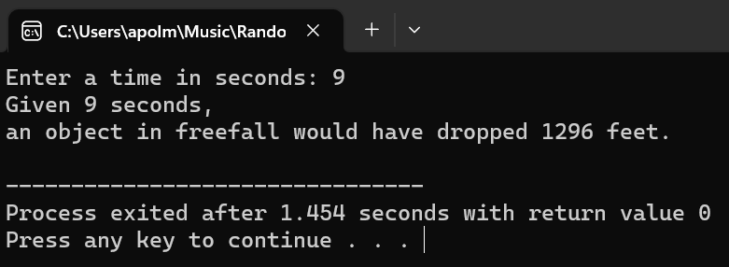

5. Prepare a program for vending machines. The cost for a sweet is $3.5. The machine can take coins in denomination of a dollar, quarter, dime or nickel and repeatedly prompting the user for the next coin to insert. The remainder amount (if exists) will be displayed. When the total or more amount is inserted, the program should output “enjoy your sweet” along with any change that should be returned. Use function.

//HW3 Q5
//Apol Medrano
#include <iostream>
using namespace std;

double coinValue(int dollarsPar,int quarterPar,int dimePar,int nicklePar);
//take monetary values put in vending machine, return total change
void changeLeftOrLeftOver (double totalPar);
//displays if you still need to insert for change
//or the amount of change you have leftover

int main()
{
int dollars=0, quarters=0, dimes=0, nickels=0;//intialize zero since C++ doesn't do it itself always
double totalChange=0;
char selection;

cout.setf(ios::fixed);
cout.setf(ios::showpoint);
cout.precision(2);

cout << "A sweet is $3.50 to purchase!" << endl;//lets user know the amount they will need to pay

while (totalChange < 3.50)//loop until totalchange is more than 3.50
{
cout << "What monetary value would you like to insert?" << endl
<< "A. Dollar" << endl
<< "B. Quarter" << endl
<< "C. Dime" << endl
<< "D. Nickel" << endl;
cin >> selection;

switch (selection)//allows vending machine user choose what coin they want to insert
{//when they choose, they get to insert the amount of that coin they have
case 'A':
case 'a':
cout << "The amount of dollars you will be inserting is: ";
cin >> dollars;
break;
case 'B':
case 'b':
cout << "The amount of quarters you will be inserting is: ";
cin >> quarters;
break;
case 'C':
case 'c':
cout << "The amount of dimes you will be inserting is: ";
cin >> dimes;
break;
case 'D':
case 'd':
cout << "The amount of nickels you will be inserting is: ";
cin >> nickels;
break;
default:
cout << "Invalid character." << endl;
}
//the total change will be updated with the new monetary value every loop
(totalChange = coinValue(dollars,quarters,dimes,nickels));
cout << "You have inserted in $" << totalChange << "." << endl;

changeLeftOrLeftOver(totalChange);//will display what is leftover or what is left to pay
}
return 0;
}

double coinValue(int dollarsPar, int quartersPar,int dimesPar,int nickelsPar)
{
double dollarsValue = 1 * dollarsPar, quarterValue = quartersPar * 0.25, //dollars & quarters values
dimesValue = dimesPar * 0.10, nickelsValue = nickelsPar * 0.05, totalValue; //dimes, nickels values

totalValue = dollarsValue + quarterValue + dimesValue + nickelsValue;//totalValue is all the coin values added
return (totalValue); //totalvalue is returned to become totalchange in the main program
}

void changeLeftOrLeftOver (double totalPar)
{
const double sweets = 3.50;
double leftorleftover;

if (totalPar < sweets)//if totalChange < 3.50 calculates money left to pay
{//also prompts vending machine user to insert more change
(leftorleftover = sweets - totalPar);
cout << "You have $" << leftorleftover << " left to pay." << endl
<< "Insert next coin." << endl << endl;
}
else if (totalPar >= sweets) //if totalChange >= 3.50 calculates their change
{//also gives vending machine user a nice message after purchasing sweet
(leftorleftover = totalPar - sweets);
cout << "You will get $" << leftorleftover << " in change." << endl << endl;
cout << "Enjoy your sweet!" << endl;
}
}

Q5 OUTPUT:
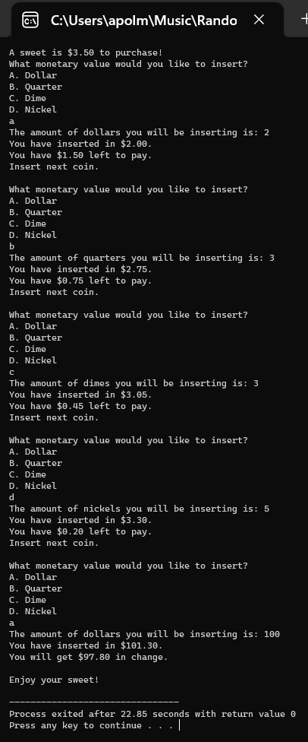

6. Prepare a function that computes the interest on a credit card account balance.
The initial balance, the monthly interest rate and the number of months for which interest must be paid will be used. The interest due is added into the balance due, and the interest for the next month is computed using this larger balance. The interest is computed for each month. Use function, loop.

//HW3 Q6
//Apol Medrano
#include <iostream>
using namespace std;

void monthlyInterest(double balancePar, double interestPar, double numberOfMonthsPar);
//calculates interest added to an existing balance for the amount of months entered
//displays updated balance for every month

int main ()
{
double balance, interest, numberOfMonths, monthsShown;

cout.setf(ios::fixed);
cout.setf(ios::showpoint);
cout.precision(2);

cout << "Intial credit card balance: ";
cin >> balance;
cout << "Interest rate on balance (write as decimal): ";
cin >> interest;
cout << "Amount of months of interest: ";
cin >> numberOfMonths;

monthlyInterest(balance,interest,numberOfMonths);

return 0;
}

void monthlyInterest(double balancePar, double interestPar, double numberOfMonthsPar)
{
for (int monthsShown=1;monthsShown<(numberOfMonthsPar + 1);monthsShown++)
{ //loops to show the balance increase for every month
balancePar = balancePar + (balancePar * interestPar);
//equation for every months interest rate added to month
cout << "After " << monthsShown << " month(s),"
<< "you're credit card balance will be "
<< balancePar << endl;
}
}

Q6 OUTPUT:
